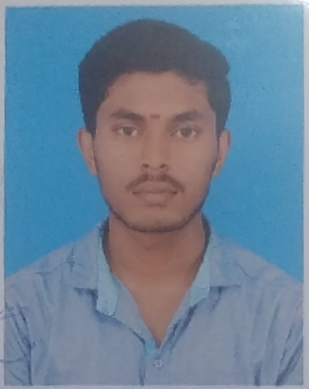

**P.SUGAVANESHWARAN**

S/o N.Poosanam,

70/302, Nesavalar Colony Main Road,

Dhadhagapatty,

Salem-636006.

sugavaneshwaran134@gmail.com

Mobile No: +91 6374734318

**CAREER OBJECTIVE**

* To secure a challenging position in a reputable organization to expand my knowledge and skills.

**ACADEMIC CREDENTIALS**

|  |  |  |  |  |
| --- | --- | --- | --- | --- |
| **COURSE** | **INSTITUTION** | **UNIVERSITY/ BOARD** | **YEAR OF**  **PASSING** | **% OF MARKS/ CGPA** |
| B.Tech (Petrochemical Technology) | Excel College of Engineering and Technology, Komarapalayam. | Anna University,  Chennai | Pursuing | 7.05  (Up to 6th Sem) |
| HSC | Gugai Hr.Sec.School, Salem. | State Board | 2017 | 79.25% |
| SSLC | Gugai Hr.Sec.School, Salem. | State Board | 2015 | 90.6% |

**TECHNICAL KNOWLEDGE**

* Programming Language : Basics of Python.
* Software process : Pro Simulator, Honey Well UNISM.
* Packages : Microsoft office.
* Operating System : windows.

**TRAINNING UNDERGONE**

* Implant Training Undergone in Central Government company like
* Steel Authority of India.
* Internship Training Undergone in most Reputed company like **“**PetroTalent**”** in the Topic of **“**Drilling and Well Control**”**.

**AREA OF INTEREST**

* Web Designing.
* App Developing.
* Process Control.
* Refineries.

**SKILL SET**

* Good at Communication.
* Problem solving.
* Team working.
* Organization.

**ACHIEVEMENT**

* Participate at. Guinness World records based on "LARGEST HUMAN IMAGE OF BANYAN TREE”, 2018.
* Completed diploma in **“**Yoga for Human Excellence**”** by WCSC-vision for wisdom” 2014.

**CO-CURRICULAR ACTIVITIES**

* Paper Presentation’s are done like Following Topics
* Green Chemistry,
* Chemical Weapon.
* Workshop’s are Done in many of the topics like
* Nano Technology in Engineering and Environment.
* MAERSK Drilling Simulation.
* Prosimulator and Pilot Distillation Units,
* Recent Trends in Drilling and Well Completion-OFFSHORE and ONSHORE,
* Pro Simulation Using Honeywell UNISM,
* Basic Simulation Using Aspen PLUS.

**PROJECT**

* Design project on **“**Water and Oil Separation**”.**
* Design Project on **“**Extraction of Bio Diesel from Waste Vegetable Oil**”.**

**PERSONAL PROFILE**

Father Name : N.Poosanam

Mother name : P.Bhuvaneshwari

Gender : Male

Date of Birth (Age) : 24-10-1999 (21)

Nationality : Indian

Religion : Hindu

Linguistic Skills : Tamil, English, Kannada.

Hobbies : Learning New Skills about Software.

**DECLARATION**

I declared here by above written particles are true to be best of my knowledge.

Date: Yours Truly,

Place: Salem (P.Sugavaneshwaran)